1. **Export – Selling Goods Abroad:**

• Meaning: Sending goods from India to another country.

Steps:

1. Get export order.

2. Prepare goods as per buyer’s specifications.

3. Arrange required licenses (DGFT, IEC).

4. Complete export documentation (invoice, packing list, shipping bill).

5. Ship via sea, air, or courier.

6. Receive payment in foreign currency.

1. **Import – Buying Goods from Abroad**

• Meaning: Bringing goods or services into India from another country.

Steps:

1. Find a reliable foreign supplier.

2. Get necessary import licenses (IEC).

3. Place order & arrange payment terms (LC, TT).

4. Goods shipped to your port.

5. Clear customs, pay import duties/taxes.

6. Transport goods to your location.

1. **Export of Services – Selling Services Abroad**

Meaning:

When a Indian service provider offers services to a client in another country, and payment is received in foreign currency.

Examples:

* IT/software development for a US client.
* Online consulting for a UK company.
* Design, legal, or accounting work for overseas firms.

Key Points:

* Payment usually via wire transfer, PayPal, or through an authorized bank.
* Must comply with RBI & FEMA regulations.
* Requires SOFTEX forms (for IT services) or GST export classification.

Benefit: Earn foreign exchange without shipping physical goods.

1. **Import of Services – Buying Services from Abroad**

Meaning:

When you hire a service provider located outside India to deliver services to you.

Examples:

* Hiring a Uk-based designer for your website.
* Paying for foreign software subscriptions (SaaS).
* Consulting from an overseas expert.

Key Points:

* May require paying IGST under Reverse Charge Mechanism (India).
* Payment made in foreign currency through authorized banking channels-AD-BANK.
* Ensure contracts clearly define deliverables and compliance with local law.

**Export Process Flowchart-**

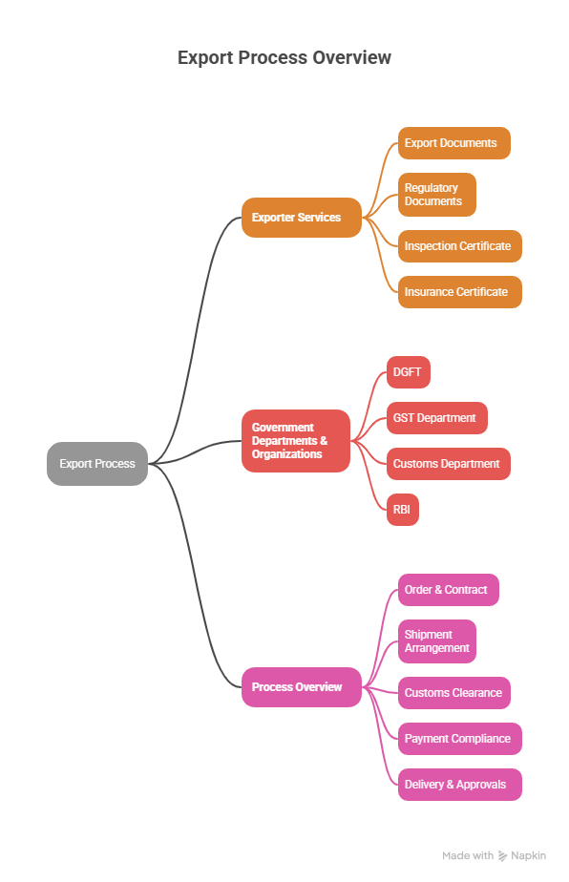**Import Process Flowchart-**